Linux s Networking Commands – Student Tasks

Part 1: Linux Basic Commands

Task 1 – File and Directory Management
Perform the following tasks:
- Display the current working directory.
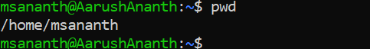
- List all files, including hidden files.
- Create a directory called linux-lab.
- Inside linux-lab, create the following directories:
  - scripts
  - logs
  - Backup
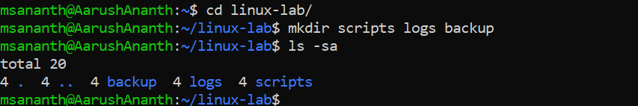
- Create three files:
  - server.txt
  - application.log
  - notes.txt
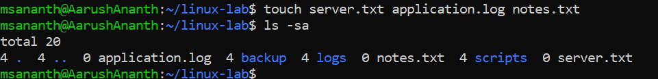
- Display the contents of the directory.
- Rename notes.txt to student-notes.txt.
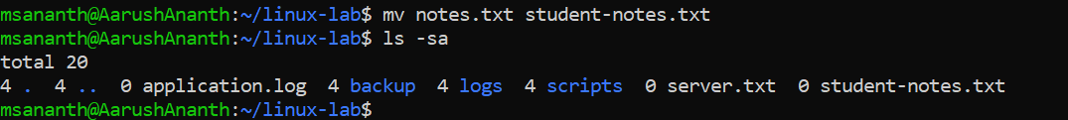
- Copy server.txt into the backup directory.
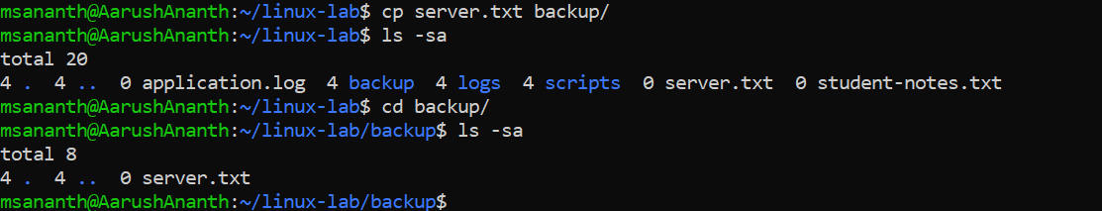
- Move application.log into the logs directory.
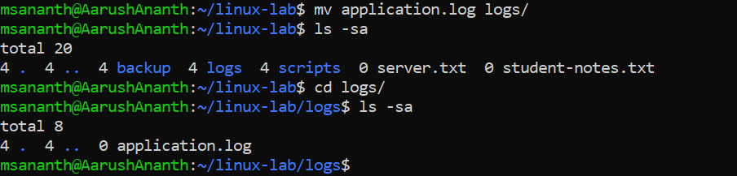
- Delete student-notes.txt.

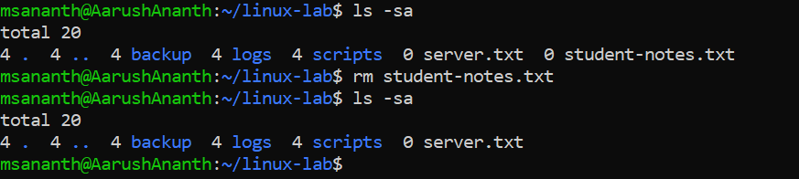

Task 2 – Working with Files
Create a file called server-info.txt and add the following information: Server Name: Linux-Server-01
Environment: Development Application: Web Application Port: 8080
Owner: DevOps Team
Perform:
- Display the complete file.
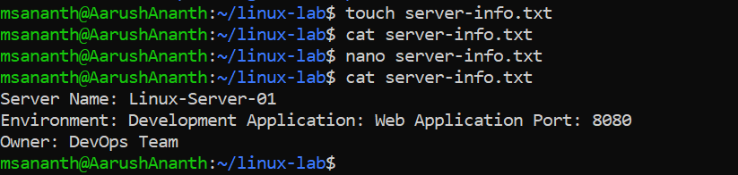
- Display only the first 3 lines.
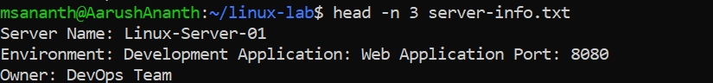
- Display only the last 2 lines.
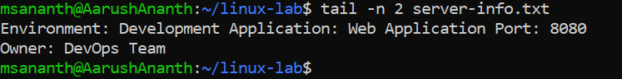
- Count the number of lines.
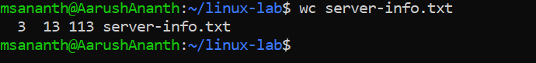
- Count the number of words.
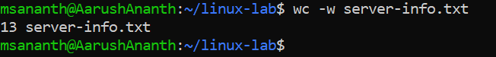
- Search for the word DevOps.
- Search for the word Server.
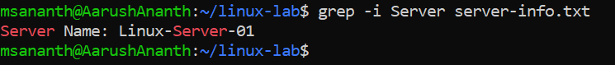
- Display the file with line numbers.
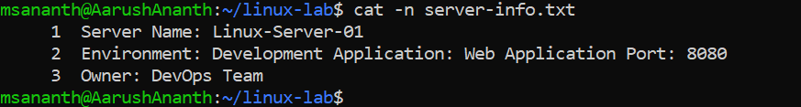

Part 2: Linux Permissions

Task 3 – File Permissions
- Create a file called deploy.sh.
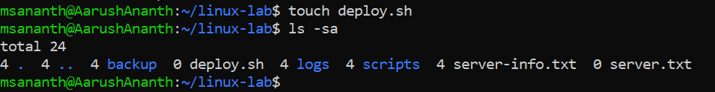
- Check its current permissions.

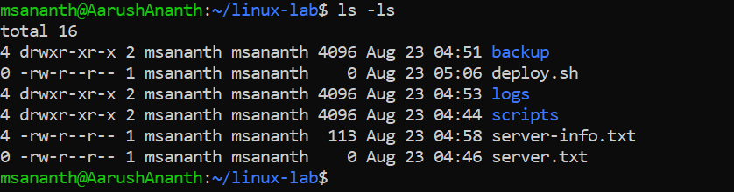
- Make the file executable.
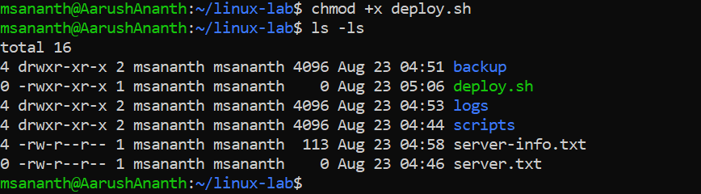
- Give the owner read/write/execute permission.
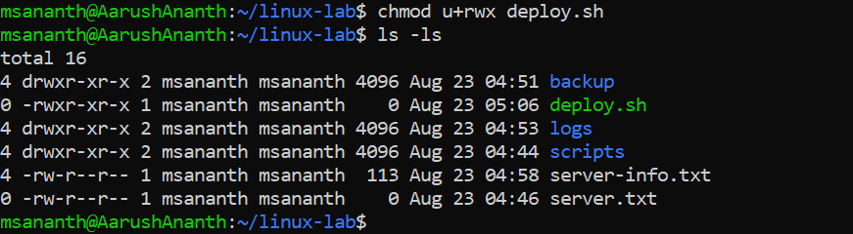
- Give the group read/execute permission.
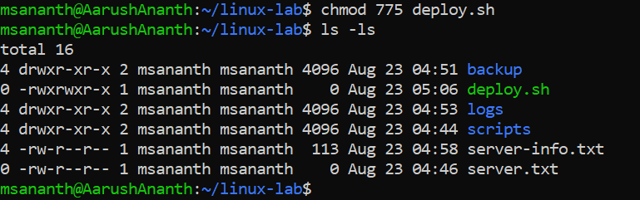
- Remove write permission from the group.
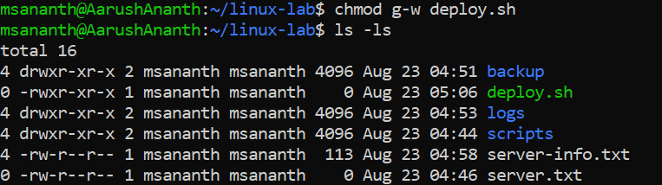
- Remove all permissions from others.
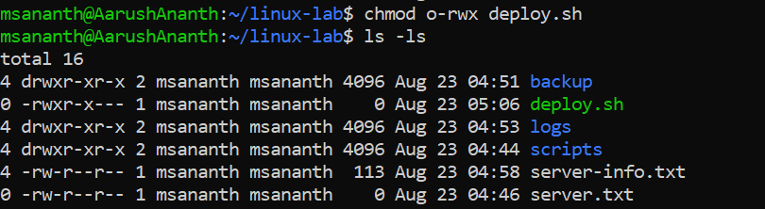
- Verify the final permissions.

Part 3: Linux Processes

Task 4 – Process Management
- Display all currently running processes.
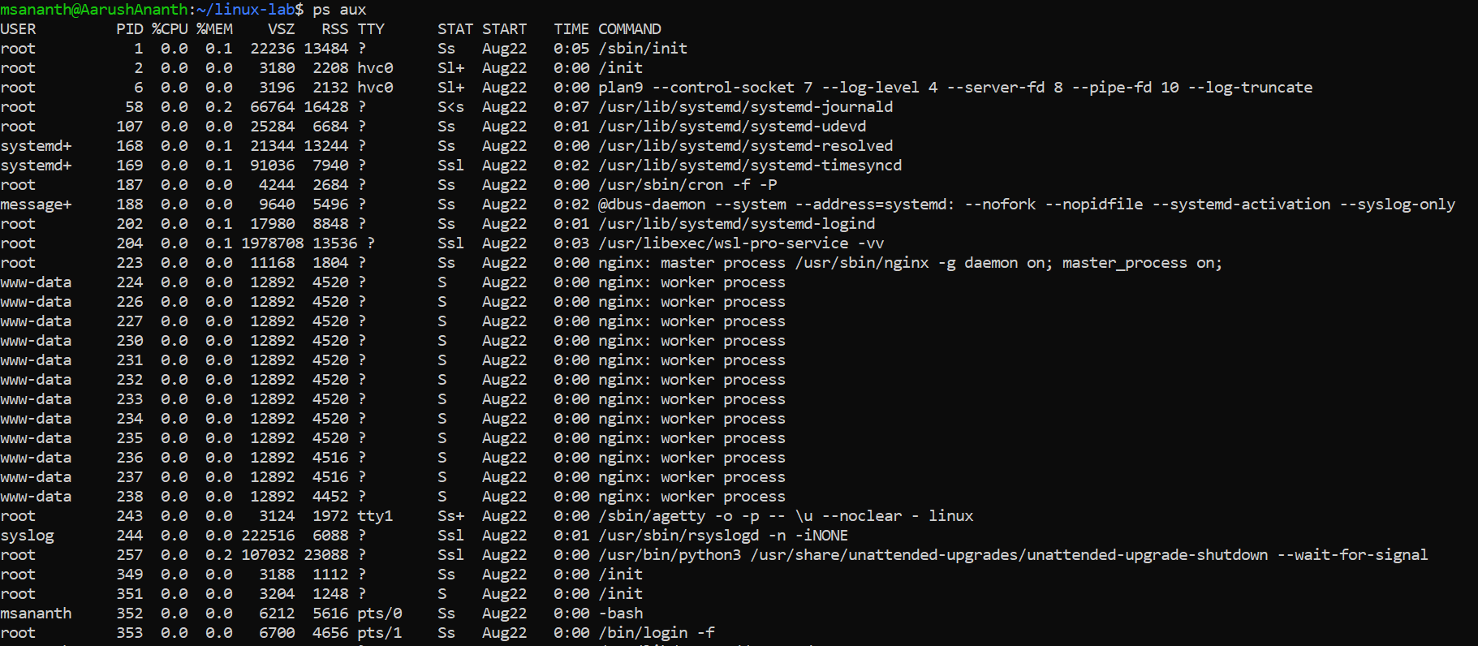
- Find the process ID of the sshd process.
- Find processes related to bash.
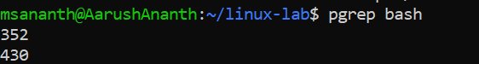
- Start a command that continuously runs.
- Find its PID.
- Stop the process.
- Display the top CPU-consuming processes.
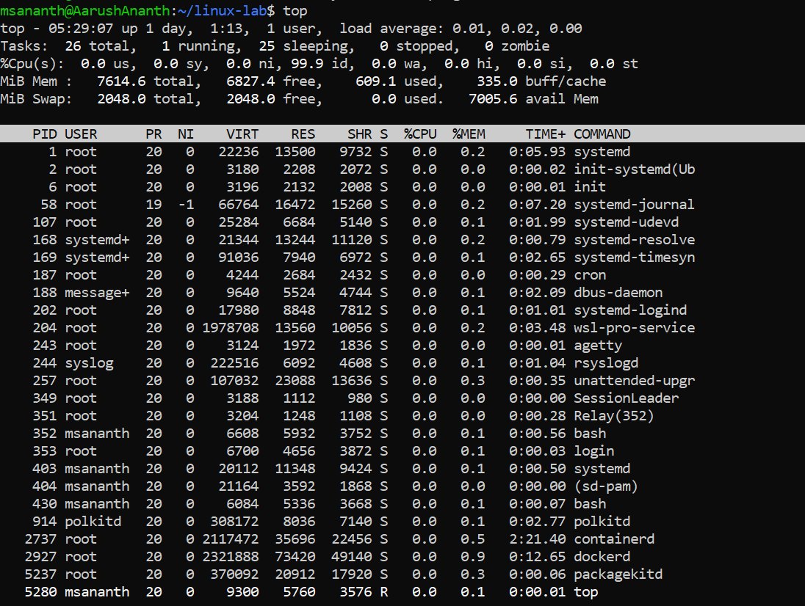
- Display memory usage of running processes.

Part 4: Linux Disk and Memory

Task 5 – System Resource Information
Find the following information from your Linux server:

- Total memory
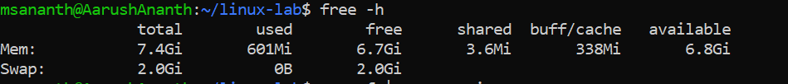
- Available memory
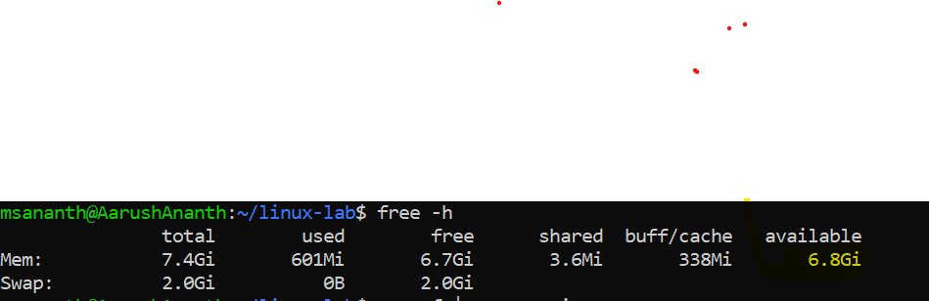
- CPU information
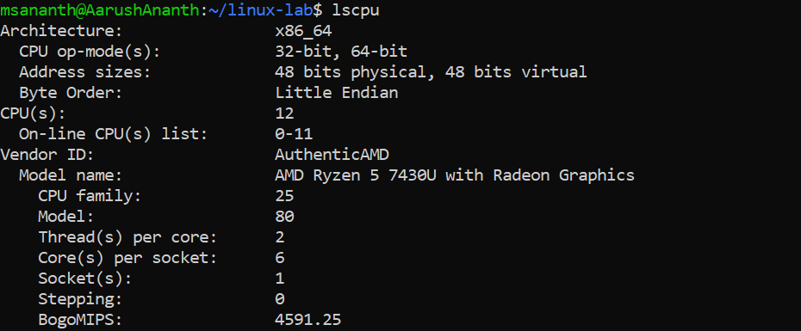
- Disk usage
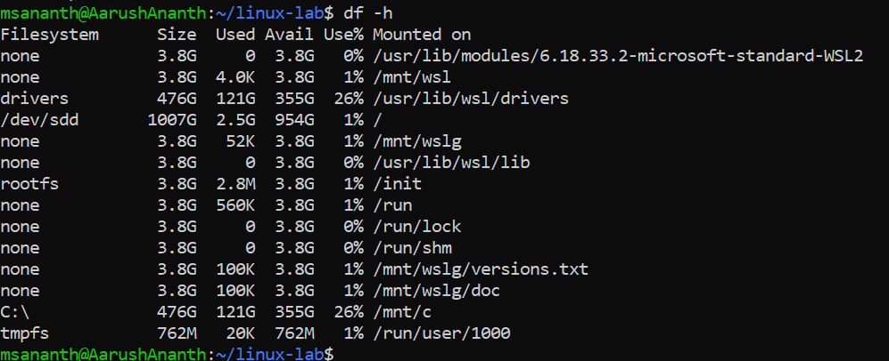
- Free disk space
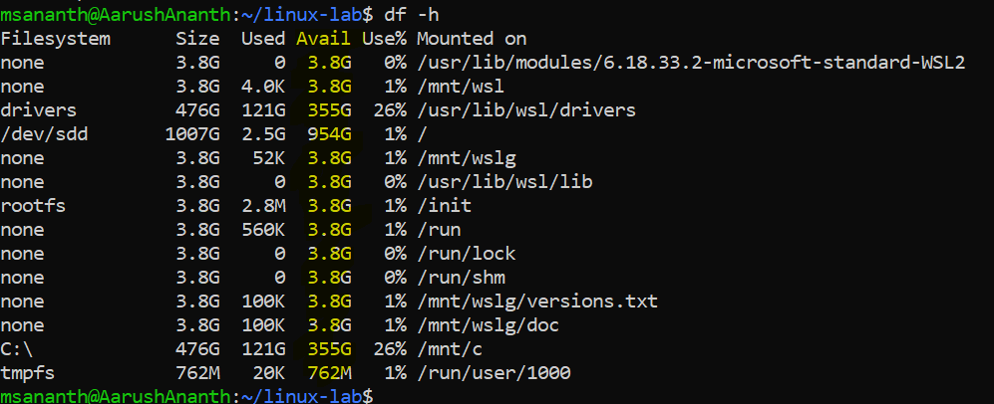
- Filesystem type
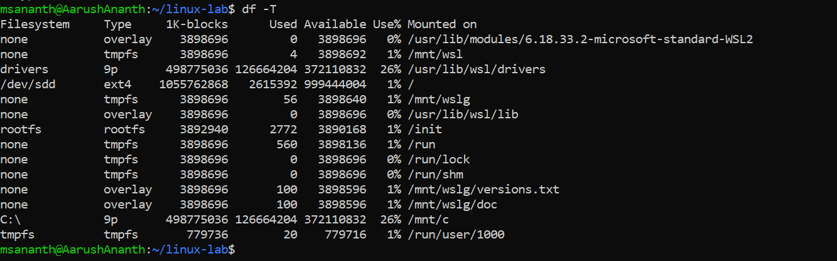
- Mounted filesystems
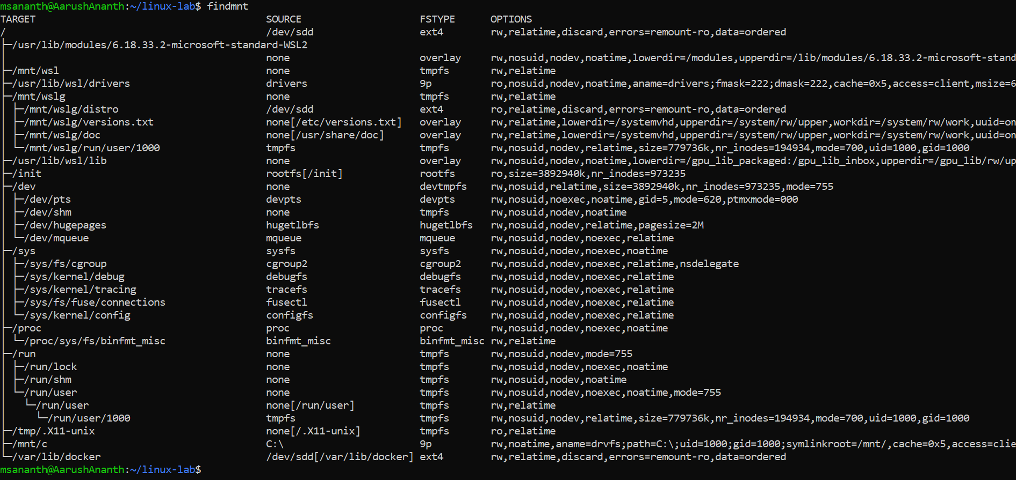
- Kernel version
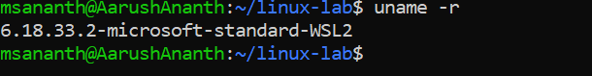
- Linux distribution/version
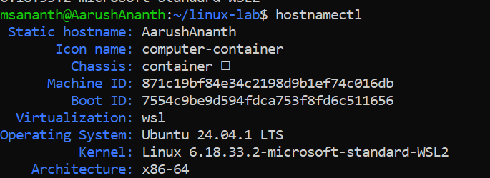
- System uptime

Part 5: Linux User Management

Task 6 – Users and Groups
Perform the following:
- Display the current username.
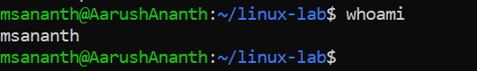
- Display the current user's UID and GID.
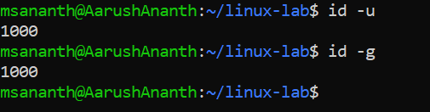
- Display all groups for the current user.
- Create a user called devopsuser.
- Create a group called devopsteam.
- Add devopsuser to devopsteam.
- Verify the user's groups.
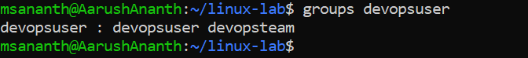
- Switch to devopsuser.
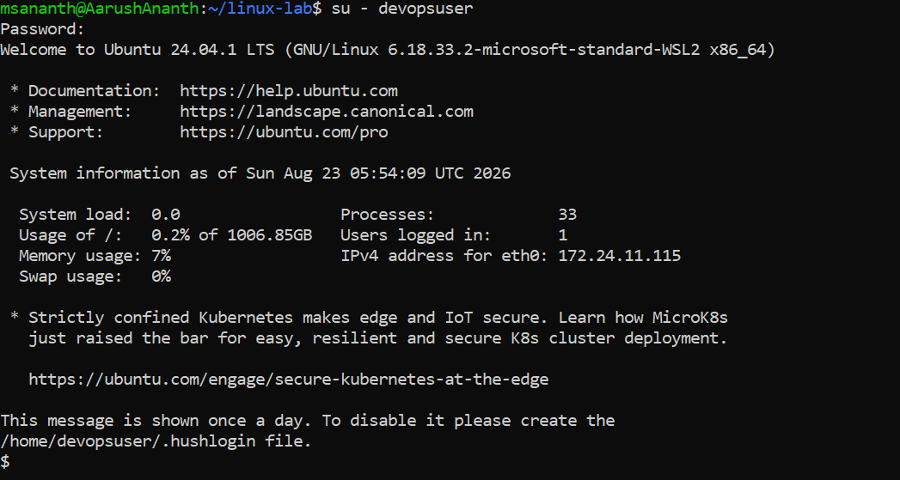
- Return to the original user.

Part 6: Networking Commands

Task 7 – IP Address Information
Find the following information about your Linux machine:
- IPv4 address
- IPv6 address
- MAC address
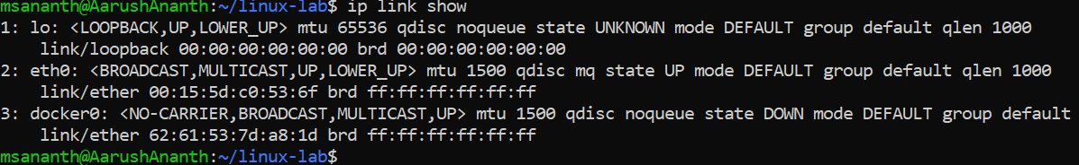
- Network interface names
- Default gateway
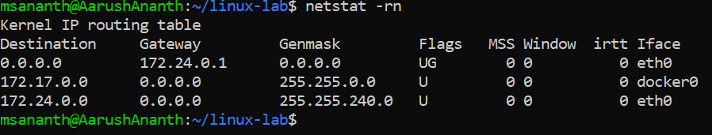
- Subnet/prefix
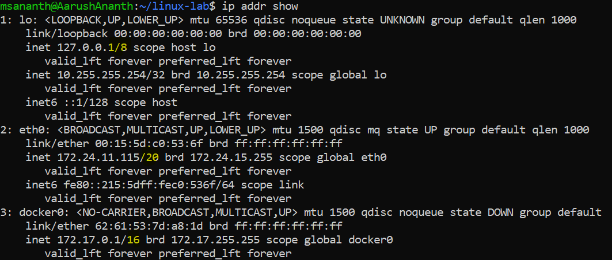

Questions
Students should answer:
  - What is your private IPv4 address?
  - What is your subnet prefix?
  - What is your default gateway?
  - What is your MAC address?
  - Does your machine have an IPv6 address?
  - How many network interfaces are present?

Task 8 – Connectivity Testing Test connectivity to the following: 127.0.0.1
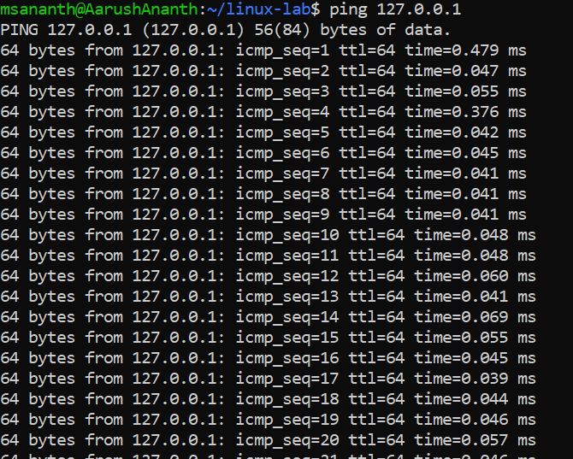
Your default gateway

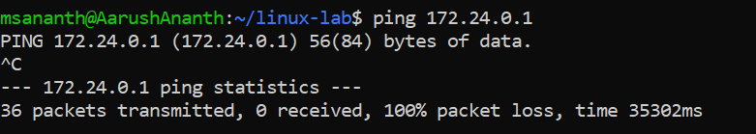
8.8.8.8
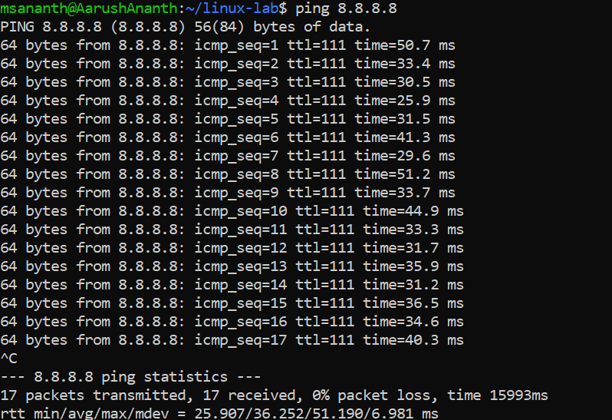
google.com
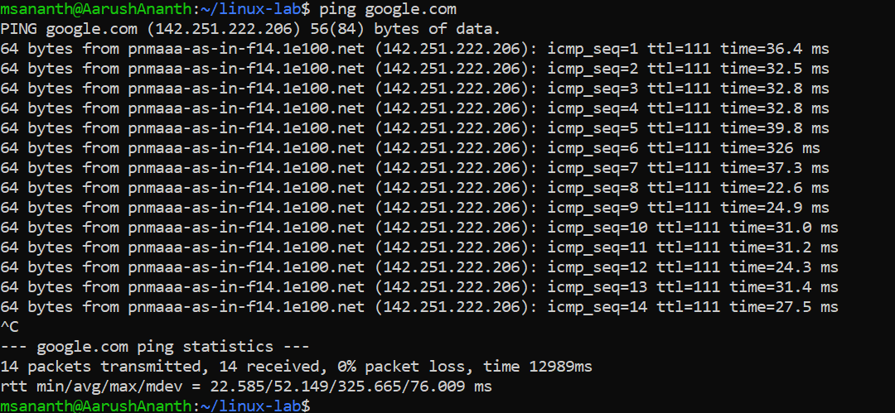
For each one:
- Test connectivity.
- Record whether it succeeds or fails.
- Check the response time.

Questions
- What is 127.0.0.1?
- What is the difference between pinging an IP address and a hostname?
- What happens if 8.8.8.8 works but google.com does not?

Task G – DNS Troubleshooting Perform DNS lookups for: google.com
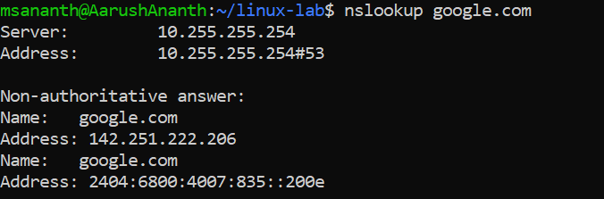
github.com
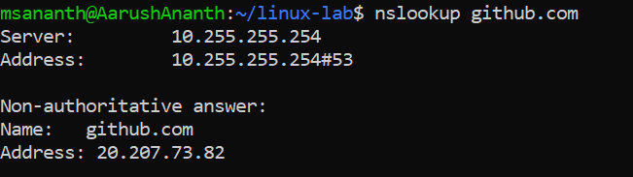
microsoft.com
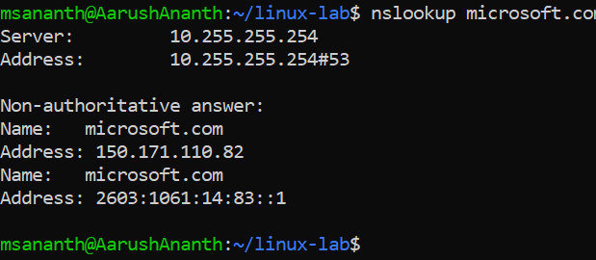
Find:
- IPv4 address
- IPv6 address
- DNS server being used
- DNS resolution time, if available

Task 11 – Network Connections and Ports
Find:

- All listening TCP ports.
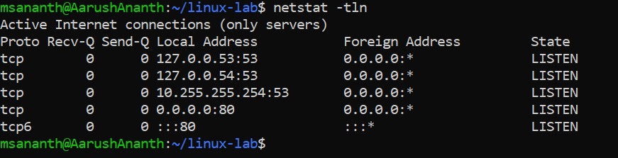
- All listening UDP ports.
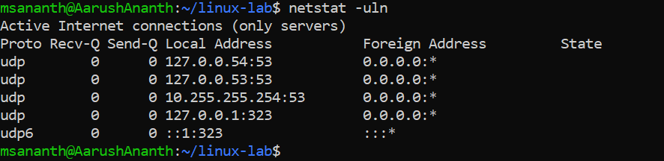
- Which process is using port 22.
- Which process is using port 80, if available.
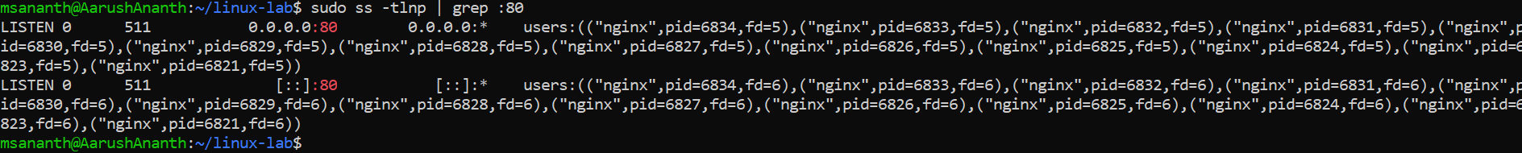
- Which process is using port 443, if available.

Questions
  - What is TCP?
  - What is a listening port?
  - What is port 22 normally used for?
  - What is port 80 normally used for?
  - What is port 443 normally used for?

Final Challenge – DevOps Network Troubleshooting

Scenario
You have a Linux server with the following problem:
The application is running on port 8080, but users cannot access the application.

Student Deliverable
Submit a document containing:
- Command used
- Command output

- What the command does
- What you observed
- Conclusion

